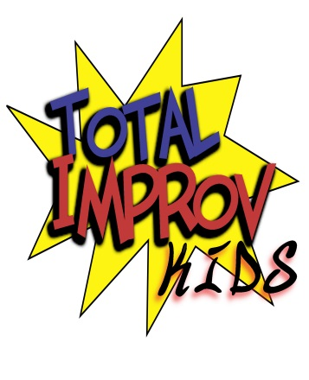

***TESTIMONIALS***

“Within Total Improv Kids’ gentle structure, (my son) can be himself in a way that is not only appreciated, but applauded by others. His social skills have blossomed because of the friendships and encouragement he has received from others in the group.”

-Marilyn Glasscock

“My son loves his weekly class and would not miss it for the world. His confidence and self-esteem have soared. Thank you Linda.”

-Gary Lane

“(Linda) has helped my daughter become a much more rounded person…she has become a great performer with the help of Linda Fulton and Total Improv Kids.”

-JoAnn Galvan

“Linda has introduced her young thespians to a wide variety of exciting opportunities, doing so with a loving, patient, enthusiastic, supportive and amazingly indefatigable spirit…We are fortunate that our son has learned so much about his passion and he too is very appreciative of Linda’s guidance, wisdom and support.”

-Kim Price

“Since knowing Linda, I have witnessed a tireless dedication to her improvisation work with children. I greatly admire and support the work she is doing…It is my belief that all children should have the opportunity to be involved in the performing arts. Most of us who are in this profession are here because someone inspired us in our youth.”

-David Farkas, Owner, Farkas Voice Institute and former Julliard instructor

***Total Improv Kids, Founder Linda Fulton***

**For Immediate Release – Los Angeles – September 2015**

**Total Improv Kids Linda Fulton – Founder/Owner**

**(818) 481-8072**

**totalimprovkids@gmail.com**

**Total Improv Kids is back with new Halloween show!**

***Top improv troupe for kids performs a brand new show every Saturday in October.***

**NORTH HOLLYWOOD –** For years, Total Improv Kids, the nation’s premiere school for teaching the art of improvisation to children, left a lasting imprint on North Hollywood with its critically acclaimed, sold-out shows at the historic Avery Schreiber Theater. Though the Schreiber closed in 2013, the work of Total Improv Kids continued and grew stronger. And now founder Linda Fulton’s class of talented performers are ready to make their return to the NoHo stage with a brand new show.

*Jack-O-Laughter* plays Saturdays in October, starting Oct. 10 from 2-3 p.m. at The Sherry Theater on Magnolia in the heart of the NoHo Arts District. As always, Total Improv Kids’ shows are run completely by kids from the moment the lights go down to the moment they come up. Taking audience suggestions, the actors will perform a series of improv games in a Halloween-themed show that Fulton swears can go toe-to-toe with any adult improv troupe performance.

“It still amazes me even today what these kids are capable of in terms of not just improv but putting together a show of their own,” said Fulton, who launched Total Improv Kids in 1999. “We have some amazing experienced performers. Mixed with the freshness and energy of some new performers, this is going to be a great show.”

While the closing of the Schreiber and the loss of a home definitely affected the young troupe, Fulton and her students banded together and dedicated themselves to the work. The result, Fulton says, is a passion and drive that she is proud to see come from her kids.

“We have been working hard and honing our skills,” Fulton said. “The community is going to see that we haven’t gone away at all, we’re still a big part of the NoHo community.”

Fulton continues to teach her improv classes and her work with local charities, offering to teach students with financial hardships and both children and adults with learning disabilities. She and her students often put up charity shows as well. The company, which has performed Off Broadway, is looking to return to New York with a new show soon as well.

Plus, Fulton has begun sharing what she’s learned from her many years working improv with students, teaching parents, educators, coaches, therapists, etc., teaching them her Fulton Method. She also has a book coming out in 2016 entitled *The Power of Improvisation.*

“With the teaching, the shows, the book, all of it—I just want to show as many people as possible how amazing improv can be in helping a child learn valuable life skill and unlocking their true potential.”

#### **Mailing Address**

#### **Theatre Unleashed**

### c/o Enlightenment Learning Center 15335 Morrison St., Ste. 145

## Sherman Oaks, CA 91403

##### For Tickets and Info:

**Call: (818) 849-4039**

**Also, check out the**

**Theatre Unleashed website at:**

**www.theatreunleashed.com**

##### Total Improv Kids

**Phone:**

**(818) 481-8072**

**E-mail:**

[**totalimprovkids@gmail.com**](mailto:totalimprovkids@gmail.com)

**www.totalimprovkids.com**

***MISSION STATEMENT:*** The mission of Total Improv Kids is to provide children an opportunity to explore their intellectual, creative and intuitive selves while promoting individual growth, responsibility, confidence, social comfort and leadership skills. With a focus on having fun, Total Improv Kids pledges to also help students hone their communication, concentration, memory and problem-solving abilities in a supportive, non-competitive environment. The ultimate goal is not only to make all children who work with Total Improv Kids better artists in the craft of improvisation, but also more well-rounded individuals, independent thinkers and leaders in the community.